Mini 6 Retro Light

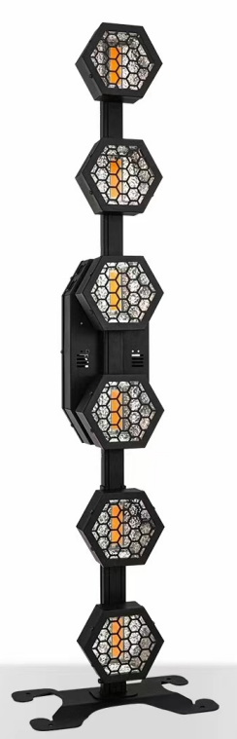

Operating Manual
1. Display Panel
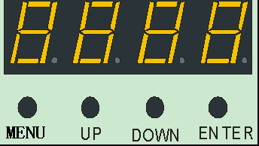
Menu confirms up and down
Key definition:
Order key: selection function
Up key:, the parameter add
Down key:, parameter parameter
Confirmation key: determine and save
2. Menu Function
After power on, press the menu button to display the menu menu; modify the function parameters up or down to save the current function and parameters (with power loss memory after saving).
menu function table:
Manu | Submenu 1 | Submenu 2 | remarks
Addr | D001/D512 |  | address code
CHAL | CH04/CH12/CH24 |  | channel
AUTO | CA50 | 01-50 | Since go
AUTO | CB50 | 01-50 | Since go
AUTO | CC50 | 01-50 | Since go
AUTO | CD50 | 01-50 | Since go
AUTO | CE50 | 01-50 | Since go
AUTO | CF50 | 01-50 | Since go
AUTO | CG50 | 01-50 | Since go
AUTO | CH50 | 01-50 | Since go
AUTO | CJ50 | 01-50 | Since go
AUTO | … |  | Since go
AUTO | DY | 01-50 | Since go
S OUD | SO01-SO99 |  | Sound control mode
STAT | c000 | c000-0255 | Operation mode, a total of 100 operating effects
STAT | r000 | r000-r255 | Red manual dimming
STAT | g000 | g000-g255 | Green manual dimming
STAT | b000 | b000-b255 | Blue manual dimming
STAT | w000 | w000-w255 | White manual dimming
STAT | t000 | t000-t255 | stroboflash
Temp | C 000 | T085 | thermoregulation
Rest | On/Off |  | factory data reset
3. Factory Setting
From A 001 to A 512, press the menu button for 5 seconds to enter the factory setting. The factory is mainly set for the functions of output power of lamps, fan setting mode, setting temperature protection point and sending parameters. The factory sets any mode and presses the menu button for 5 seconds.

Factory Settings Table:
R255 |  | R032 | Modify the red bead current (R032~ R255), confirm the key is saved, default R220.
G255 |  | G032 | Modify the green bead current (G032~G255), confirm the key save, default G220.
B255 |  | B032 | Change the blue bead current (B032~ B255), confirm the key save, default B220.
W255 |  | W032 | Modify the white lamp bead current up or down (w 032~ w 255), confirm that the key is saved, default w 220.
Dir0 |  | Dir7 | Modify the flow direction up or down (d 0~ d7), save the key, default d0.
FAN0 |  | FAN1 | Fan setting: the FAN 0 lamp bead light will start the fan, the FAN 1 temperature reaches 40 degrees to start the fan, confirm the key to save.
T040 |  | T 070 | Set the temperature protection point, modify the parameters up or down (40℃ ~70℃), press the confirmation key to save, default T065.
S end |  | S end | Send the factory setting parameters up or down to all other lamps connected in parallel with three-core signal lines; confirm the sending parameters, press the dish order key for 5 seconds to exit, and press the confirmation key to cancel the sending.
4. Master-slave Control
Two or more identical lamps are connected with DMX three-core signal line, all lamps are set as A001~A512 any address code, any one is set as the host, other lamps are slave, all slave display screens are not flashing; when the host adjusts the gradient, pulse, voice control and self-walking effect, all slave synchronous gradual, ripple, voice control and self-walking effect.
Special attention: 1.a group of lamps can only be set with one host, if there are more than one host, all the lamps will flash and not synchronized.
2.All lamps must be used when the DMX512 console is closed.
5. DMX512 Channels
After power-on, all the lamp address codes are set, and then all the lamps are connected to the DMX512 console in parallel with three-core signal lines. The address code will stop flashing, indicating that the DMX512 console signal has been sent to the lamp, and the relevant functions are controlled with the DMX512 console according to the instructions of the channel table.

4CH Description:
CH4 | Value | Function
1 | 000-255 | Red total dimming
2 | 000-255 | Green total dimming
3 | 000-255 | Blue total dimming
4 | 000-255 | White total dimming

12CH Description:
CH12 | Value | Function
1 | 000-255 | Total dimming
2 | 000-255 | stroboflash
3 | 000-255 | pigment
4 | 000-255 | Effect mode (106 effects), 255 is voice control
5 | 000-255 | velocity
6 | 000-255 | White light screen flash
7 | 000-255 | White light effect mode (73 effects) with lower priority than voice control
8 | 000-255 | White light speed
9 | 000-255 | Red lamp bead background linear dimming
10 | 000-255 | Green lamp bead background linear dimming
11 | 000-255 | Blue lamp bead background linear dimming
12 | 000-255 | White lamp bead background linear dimming

144CH Description:
CH24 | Value | Function
1 | 000-255 | R segment 1 red lamp bead linear dimming
2 | 000-255 | G Linear dimming in paragraph 1
3 | 000-255 | B Linear dimming in segment 1
… | … | … …
16 | 000-255 | R segment 6 red lamp bead linear dimming
17 | 000-255 | G Linear dimming in paragraph 6
18 | 000-255 | B The linear dimming of the blue lamp beads in segment 6
19 | 000-255 | W linear dimming of white lamp beads in paragraph 1
… | … | … …
24 | 000-255 | W segment 6 white lamp bead linear dimming

- Technical Parameters
Voltage: AC100 ~ 220V 50 / 60HZ
Power: 144 * 0.3W + 6 * 50W
Beads: 144 5050 three-color LED beads + 6 warm white COB beads
Control mode: DMX512, self-walking, master-slave, voice control, with RDM function.
Channels: CH04, CH12, CH24
Dimming: 32 bit 0 ~ 100% linear dimming
Features: dyeing + explosion flash + auxiliary light
Operating temperature: -30 degrees ~ 50 degrees
Strobe frequency: 1 ~ 30 HZ
Appearance: metal, black
Connection mode: DMX512 I / O / Power I / O. IP Level: IP20
7.Product Size and Packing
Product Size:32*19.5*114cm
Inside Carton Packing Size:118*21*21cm
Outside Carton Packing Size:120*45*24（2in1）
Net Weight:6.05kg
Gross Weight :16.3kg (2in1)
Power Cable*1, Signal Cable*1, Manual*1

